Ex. No.: 4

Date:

**SELECT with various clause – WHERE, pattern matching**

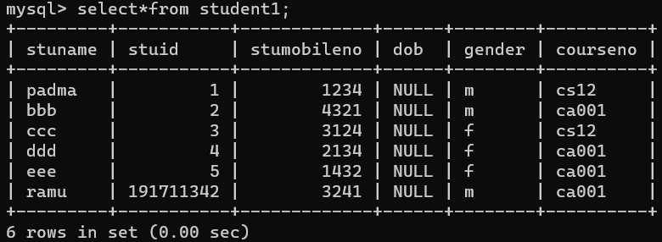

1. The controller of examinations wanted to list all the female students

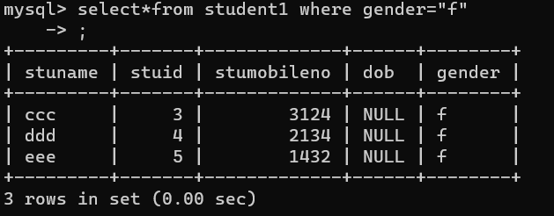

1. Who are the boy students registered for course with the course number “C001“

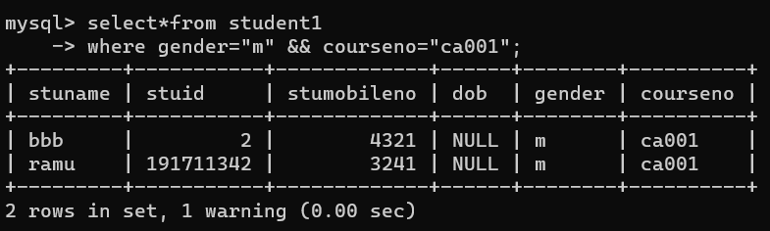

1. List the students whose name ends with the substring “ma”

